Chapter 14 Notes
Lesson 1
Energy is ______________________________________________
Energy can change an objects _______, _______, _______, _______, ____________.
Every time energy changes form, some energy is given off as _______________
ENERGY CANNOT BE __________________ OR _____________________. IT CAN MOVE FROM ONE OBJECT TO ANOTHER. THIS IS CALLED THE LAW OF CONSERVATION OF ENERGY

Examples of the transfer of energy:
- Energy in a firework changes from chemical energy to ________________, ________________, and _________________
- Energy in a radio changes from electrical energy to __________________.

 | Definition/Notes | Example
Kinetic Energy
Potential Energy

 | Definition/Notes | Example
Chemical Energy
Nuclear Energy

Lesson 2
Vocabulary Term | Definition
Crest

Trough

Wavelength

Decibels

Draw the appropriate wavelength
Loud sound

Soft sound

High pitch

Low pitch

Lesson 3
Light travels in the same ways that sound does – in wavelengths and frequencies; however, light is different from sound in many ways.

Light is a combination of _______________ and _______________. It travels through space in the form of ________________ ________________.
Explain
Electromagnetic radiation

Different wavelengths of visible light are seen as different colors.
Draw the electromagnetic spectrum and label the wavelengths

Convex and Concave Lenses
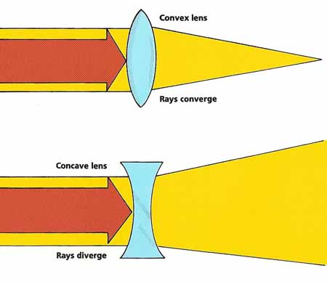
Convex lenses bend light rays to make objects look _____________.
Concave lenses bend light rays to make objects look _____________.
Lesson 4
What is thermal energy? __________________________________________________________________________________________________________

A change in thermal energy can lead to a change in _______________.
When the thermal energy of a substance increases, its particles move ____________________________.
When the thermal energy of a substance decreases, its particles move
____________________________.

Heat moves in three ways:
Conduction

Convection

Radiation

